

**SECD 2613**

**System Analysis and Design**

**Section 7**

**Group 2**

**Theme: Campus Resource Management System**

**Module 1: Facility Booking and Management**

**Lecturer:** DR.ROZILAWATI BINTI DOLLAH @ MD ZAIN

**Group member:**

|  |  |
| --- | --- |
| Name | Matric number |
| Austin See Yong Hui | A23CS5015 |
| Mohamed Adel Abdullah | A23CS4061 |
| Faisal Abdulhakim Bakouban | A23CS0015 |

Table of contents

**1.0 Introduction** 1

**2.0 Background study** 2

**3.0 Problem statement** 3

**4.0 Proposed solution** 3

**4.1 technical feasibility** 5

**4.2 operational feasibility** 5

**4.3 economic feasibility** 6

**5.0 Objectives** 8

**6.0 Scope of the project** 10

**7.0 Project planning** 11

**7.1 human resource** 11

**7.2 WBS** 11

**7.3 PERT chart** 12

**7.4 Gantt chart** 13

**8.0 Benefit and overall summary of the proposed system** 14

**9.0 Project Management** 15

# **1.0 Introduction**

The Event Management module of the Campus Resource Management System (CRMS) is designed to simplify organizing and managing events on a university or college campus. It provides a centralized platform where administrators, faculty, and students can easily schedule, reserve venues, register attendees, and promote events. With this module, campus communities can stay informed and engaged with all the exciting events happening around them. It is all about enhancing efficiency, communication, and resource utilization on campus.

# **2.0 Background study**

Traditionally, event management involves multiple manual processes, such as paper-based scheduling, venue reservation, and attendee registration. These processes can be time-consuming, prone to errors, and lack efficient communication channels. As a result, it can be challenging for event organizers to coordinate with various departments, faculty members, and students involved in the event.

**1-Current Processes and Systems**

Investigate the existing methods and systems used for event management within the campus. This includes manual processes, spreadsheets, standalone event management software, and any other tools currently in use. Identify pain points, inefficiencies, and areas for improvement.

**2-Resource Utilization:**

Analyze the use of campus resources like venues, equipment, and personnel for hosting events. Determine the availability, capacity, and scheduling constraints of different facilities and resources to optimize their usage and avoid conflicts.

**3-Communication and Collaboration:**

Assess the effectiveness of communication channels and collaboration tools used for coordinating events. Identify gaps in communication, delays in information dissemination, and challenges in collaborative planning among event organizers and stakeholders.

**4-Technology Infrastructure:**

Evaluate the existing technology infrastructure and IT capabilities within the campus. Determine the feasibility of implementing a centralized Campus Resource Management System (CRMS) and integrating it with other campus systems and databases.

# **3.0 Problem statement**

**1. Inefficient event scheduling:**

Currently, event scheduling on campus involves manual processes, such as paper-based forms or scattered digital platforms. This leads to conflicts, double bookings, and difficulties in coordinating with various departments. The CRMS Event Management module aims to streamline the scheduling process and provide a centralized platform for efficient event planning.

**2. Limited venue utilization:**

Without a comprehensive system, it can be challenging to track venue availability and optimize resource utilization. The CRMS Event Management module seeks to address this issue by providing real-time venue availability, allowing for better utilization of campus facilities.

**3. Lack of effective communication:**

Communicating event details, updates, and reminders to attendees can be time-consuming and prone to errors. Manual methods, such as email chains or physical notices, may result in miscommunication or missed information. The Event Management module in CRMS aims to enhance communication by providing automated notifications and reminders, ensuring that all relevant parties stay informed.

**4. Difficulty in attendee registration:**

Traditional methods of attendee registration, such as paper forms or manual spreadsheet management, can be cumbersome and prone to errors. This can lead to delays in processing registrations and difficulties in managing attendee lists. The CRMS Event Management module offers an integrated registration system, simplifying the process and allowing for efficient management of attendee data.

# **4.0 Proposed solution**

Sunbucks is a system that allows users to have convenience and accessibility on searching, viewing availability, and booking campus facilities such as classrooms, auditoriums, labs, and sports fields. The system also allows the facility managers to define booking policies, manage reservations, and track resource utilization.

Primarily, a user-friendly interface that is accessible via web browser will be provided. This ensures the ease of sue for all stakeholders including students, faculty, staff and admistrators. A secure login system with role-based access control will be included in the system to ensure that users only have access to functionalities appropriate to their roles. Different user roles would be defined, such as students, faculty, staff, and facility managers, each with varying levels of access permissions.

To ease the process of searching, viewing availability, and booking campus facilities, a centralized dashboard will be implemented in the system which helps facility search and availability. The dashboard will show the availability of campus facilities such as classrooms, auditoriums, labs, sports fields etc. so that the users would be able to search for available facilities based on criteria such as location, type, capacity, and amenities. The system would display real-time availability, allowing users to see which facilities are free for booking at any given time. Also, there will be an administrative dashboard where the administrators have access to the centralized dashboard. They can monitor system activity, manage user accounts, configure system settings, and generate comprehensive reports on facility utilization and performance metrics.

The next feature of the system will be booking management. With the centralized dashboard discussed above, the users could reserve facilities through an intuitive booking interface. They can specify the date, time, duration, and purpose of the booking. Once a booking is confirmed, the system will update the availability status accordingly. As a facility booking and management system, resource utilization tracking will be undeniably important. The system would track the utilization of each facility, providing insights into usage patterns, peak times, and overall resource efficiency. Facility managers can generate reports to analyze trends and optimize resource allocation based on data-driven insights.

The last feature will be feedback and reviews. After using a facility, users would have the option to provide feedback and ratings based on their experience by writing comments or sharing pictures of facilities used. The users review will be visible by the other users. This helps in continuously improving the quality of services and addressing any issues promptly.

## **4.1 technical feasibility**

Implementing a new CRMS involves various technical challenges. However, it is technically feasible for a university with adequate resources, expertise, and careful planning. Successful implementation requires collaboration among stakeholders and effective project management. A university has a lot of expert staff and students from various aspects of faculty of computing such as software engineering, data engineering, graphic and multimedia software and cyber security. This ensures the process of developing an intuitive and user-friendly interface for the facility booking system can be done. The user experience (UX) design and user interface (UI) design created will be able to meet the needs of various stakeholders. Also, university would have the ability to set up and manage databases effectively, ensuring data integrity, security, and scalability.

## **4.2 operational feasibility**

A CRMS will be operational feasible especially for a facility booking and management system. This is because this system will meet the needs of users such as students and staff when they need a space to conduct short term events or activities. With the features provided by the system, even year 1 university students can apply to book and use the existing facilities inside campus. Apart from that, the system will allow and ease the management of faculties on the facilities available. This solves the problems of unuse facilities inside campus as the management is able to track the usage of the facilities. A report based on the usage of facilities allows the management to make improvements and maintenance to the overused and underused facilities.

## **4.3 economic feasibility**

|  |  |
| --- | --- |
| **Estimated cost** | |
| Hardware | RM 15000 |
| Software | RM 10000 |
| Advertisement | RM 4000 per year |
| Maintenance | RM 5000 per year |
| Training expense | RM 3500 per year |
| IS support | RM 3000 per year |

|  |  |
| --- | --- |
| **Estimated benefits** | |
| Cost reduction | 20000 |
| Improved resource utilization | 15000 |
| Productivity increased | 10000 |

|  |  |
| --- | --- |
| Assumption | |
| Discount rate | 10% |
| Sensitivity factor(cost) | 1.1 |
| Sensitivity factor(benefits) | 0.9 |
| Annual change in production cost | 5% |
| Annual change in benefits | 7% |

Cost-Benefit Analysis

|  |  |  |  |  |  |
| --- | --- | --- | --- | --- | --- |
| **Cost** | **Year 0** | **Year 1** | **Year 2** | **Year 3** | **Year 4** |
| **Development cost** |  |  |  |  |  |
| Hardware | 16500 |  |  |  |  |
| Software | 11000 |  |  |  |  |
| **Total**  **(Development cost)** | 27500 |  |  |  |  |
|  |  |  |  |  |  |
| **Production cost** |  |  |  |  |  |
| Advertisement |  | 4400 | 4620 | 4851 | 5094 |
| Maintenance |  | 5500 | 5775 | 6064 | 6367 |
| Training expenses |  | 3850 | 4043 | 4245 | 4457 |
| IS support |  | 3300 | 3465 | 3638 | 3820 |
| **Annual**  **production costs** |  | 17050 | 17903 | 18798 | 19738 |
| **Present value** |  | 15500 | 14796 | 14123 | 13481 |
| **Accumulated cost** |  | 43000 | 57796 | 71919 | 85400 |

|  |  |  |  |  |  |
| --- | --- | --- | --- | --- | --- |
| **Benefit** | **Year 0** | **Year 1** | **Year 2** | **Year 3** | **Year 4** |
| Cost reduction |  | 18000 | 19260 | 20608 | 22051 |
| Improved resource  utilization |  | 13500 | 14445 | 15456 | 16538 |
| Productivity  increased |  | 9000 | 9630 | 10304 | 11025 |
| **Annual benefit** |  | 40500 | 43335 | 46368 | 49614 |
| **Present value** |  | 36818 | 35814 | 34837 | 33887 |
| **Accumulated cost** |  | 36818 | 72632 | 107469 | 141356 |
| **Gain or loss** |  | (6182) | 14836 | 35550 | 55956 |
| **Profitable index** | 2.035 | | | | |

Even though there is some loss in the first year when the system is implemented. However, the profitable index is greater than 2.035 which is greater than 1.0 showing that the project is a good investment.

# **5.0 Objectives**

It is necessary to create and install a module for the Campus Resource Management System (CRMS) that makes it easier to manage campus events, reserve venues, register attendees, communicate, and use resources. The objective is to provide an efficient, user-friendly online interface that is accessible to various stakeholders. Role-based access control, centralized dashboards for venue availability search and check, user-friendly booking interfaces, resource utilization tracking, and feedback methods for ongoing enhancements should all be features of this interface.

The following elements have to be included in order to do this:

1.User-Friendly Interface: All stakeholders should be able to easily browse and utilize the user interface, and it should guarantee that all functionalities are easily accessible.

2. Role-Based Access Control: To guarantee that private data is safeguarded and that features are customized to the user's role, a secure login system with role-based access control should be put in place.

3. Centralized Dashboards: Centralized dashboards for facility search and availability should be developed in order to offer real-time information on venue availability, capacity, amenities, and scheduling limitations.

4. Intuitive Booking Interfaces: Users should be able to select the date, time, duration, and purpose of their reservation using an intuitive booking interface, which should also give them with rapid access to the availability status after confirmation.

5. Resource Utilization Tracking: To analyze facility usage patterns, peak times, and overall resource efficiency and provide data-driven insights for optimization, a comprehensive resource utilization tracking system should be implemented.

6. Automated Notifications and Reminders: To enhance communication, automated notifications and reminders for event information, updates, and registration should be put into place. This will guarantee that accurate and timely information is shared.

7. Feedback systems: It is recommended to have feedback mechanisms that enable users to offer ratings, evaluations, and comments regarding their experiences with the facility. This will allow for ongoing development and quick resolution of any problems.

# **6.0 Scope of the project**

The scope of the project encompasses the entire lifecycle of developing and implementing the Campus Resource Management System (CRMS) Event Management module. This includes:

1. **Requirements Gathering:** Collaborating with stakeholders to gather functional and technical requirements for the system.
2. **Design:** Creating the system architecture, user interface design, and database structure.
3. **Development:** Writing code, integrating features, and implementing security measures.
4. **Testing:** Conducting unit testing, integration testing, and user acceptance testing to ensure functionality and quality.
5. **Deployment:** Deploying the system in a production environment and configuring for live usage.
6. **Training and Documentation:** Providing training sessions for users and administrators and creating documentation for system usage and maintenance.
7. **Maintenance and Support:** Offering ongoing maintenance, updates, and technical support for the system post-deployment.

# **7.0 Project planning**

## **7.1 human resource**

Project manager: Austin See Yong Hui

* Manage the task
* Assign task to members
* Make correction to the task

Designer: Faisal Abdulhakim Bakouban

* Design for the system interface
* Design prototype

Advisor: Mohamed Adel Abdullah

* Give advises for improvement
* Track the progress

## **7.2 WBS**

Facility booking and management

Project initiation

Requirement gathering

System design

Testing and Deployment

Development

Maintenance

Define Project Scope

Set Project Objectives

Identify Stakeholders

Conduct User Interviews

Analyze Existing Systems

Architectural Design

Security Design

Interface Design

Implement User Interface

Implement User Authentication

Conduct Training Sessions

Implement Updates and Enhancements

Unit Testing

Deploy system

## **7.3 PERT chart**

|  |  |  |  |
| --- | --- | --- | --- |
| Activity | Description | Predecessor | Duration |
| A | Project initiation | - | 1 day |
| B | Requirement gathering | A | 3 days |
| C | System design | B | 4days |
| D | Architectural design | C | 1day |
| E | Interface design | C | 2 days |
| F | Security design | C | 2 days |
| G | Implement user interface | E | 2 days |
| H | Implement user authentication | D, F | 3 days |
| I | Unit testing | G, H | 4 days |
| J | Deploy system | I | 2 days |
| K | Conduct training sessions | J | 7 days |
| L | Implement updates and enhancements | K | 6 days |

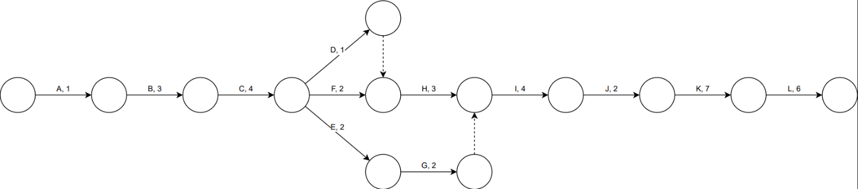

## **7.4 Gantt chart**

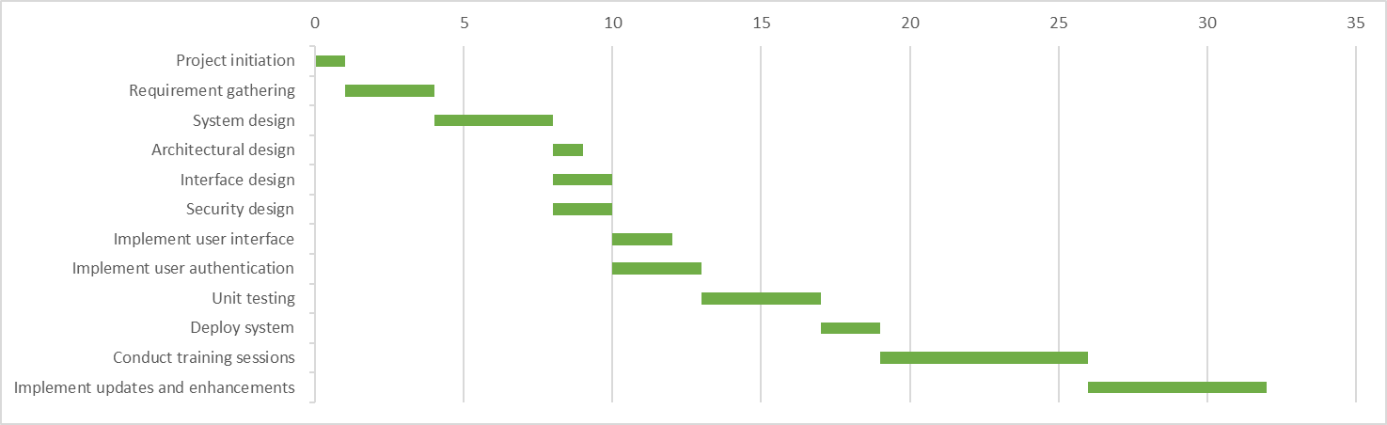

**8.0 Benefit and overall summary of the proposed system**  
  
For colleges and universities, the Campus Resource Management System (CRMS) has added an Event Management feature. This module replaces manual procedures with a centralized platform to streamline event planning and management. It provides advantages like increased productivity, more effective use of resources, smoother communication, easier registration for attendees, an intuitive interface, and extensive feedback mechanisms. Data security and accessibility are guaranteed by the module's role-based access control and user-friendly interface. By allowing users to rate, assess, and remark on their event experiences, the feedback systems promote ongoing development. All things considered, the CRMS Event Management module provides a streamlined and intuitive platform that enables stakeholders to easily plan, organize, and participate in events. By increasing productivity, the module adds to a lively campus community and enhances the university experience in general.

# **9.0 Project Management**

GitHub repository URL:

<https://github.com/YongHuiGH/SAD-SECD2613---SECTION-07-232402->

Repository snapshot:

